

*ISTITUTO COMPRENSIVO TREMESTIERI*

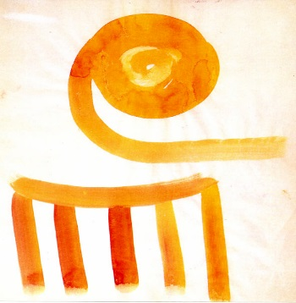





# 

# **Guache di Salvatore Quasimodo**

*(esposta nella Torre Saracena)*

**Erasmus+ Project :** "**Technology for learning and creativity: weaving European networks through collaborative music creation"**

**(ID Number: 2015-1-ES01-KA201-016139)**

**Student mobility to Sicily - program draft**

**Saturday (14/05/16)**

**Valencian Group arrival (24 people)**

**Romanian group arrival (6 people):**

**Portuguese group arrival (6 people):**

**Transportation to lodging**

**Free afternoon to visit the city, meet with partners, etc.**

**21h Wellcome Dinner : Restaurant “ Da Silvia “**

**Sunday (15/05/16)**

**9:00 Cultural visit in Taormina (10 minute drive from Roccalumera)**

**13: 30 Lunch in Roccalumera**

**16h to 20h Soundcool Rehearsal 1 (each partner will have a rehearsal with their group about the City performance) in Roccalumera (Quasimodo Literary park )**

**17h00 Project management meeting**

**18,30 (Concert in Roccalumera-Parco Quasimodo )**

**21h Dinner in Roccalumera**

**Arrival subgroup1 valencia (2 people- major and vice-major of Alcàsser)**

**VY6244 Valencia- Roma 18:50-20:45**

**VY66138 Roma- Catania 22:15-23:35**

**Monday (16/05/16)**

**Roccalumera : Quasimodo Literary Park**

**Morning**

**9h to 12,00h Soundcool Rehearsal (each group separate)**

**12h30 to 13h30 Common rehearsal (each group will show the performances to the other partners)**

**14h00 Lunch**

**Afternoon**

**16h to 18h Soundcool Rehearsal 3**

**20.00 : Multicultural evening with ANOLF Messina ( food , drink and multiethnic music )**

(with flag of Spain , Romania and Portugal )

**Tuesday (17/05/16)**

**8:15 meeting in the hotel or in apartements**

**Departure to MESSINA (Tremestieri School) –**

**Morning**

**9h to 13,30h Soundcool Rehearsal 4**

**4h00 Lunch**

**Afternoon**

**16h to 18h General Rehearsal**

**17h30 Soundcool Concert**

**19:15 Departure to Roccalumera**

**Dinner (Rest . l’Etoile)**

**Wednesday (18/05/16)**

**Morning**

**Departure to MESSINA**

**( Train in Roccalumera h 9:12 – Arrival in Messina 10:08)**

**10h to 12h30 Cultural Visit (Visit of del Center Town with Cathedral ( il Duomo ), Catalan’s Church , Harbour etc )**

**Lunch**

**Only For Portuguese group and part of Valencian group (7 people) transfer to Catania Airport**

**18 Maio 16          Catânia / Roma                TP # 7202            16H50 / 18H10**

**18 Maio 16          Roma / Lisboa                  TP # 0843            19H35 / 21H40**

**18 May Vy6135 Catania-Roma 15:50-17:15**

**18 May Vy6245 Roma-Valencia 19:35-21:40**

**15:00-18:30 – Soundcool concert**

**Departure to Roccalumera**

**21: Farewell Dinner - S. Teresa di Riva**

**Tuesday (19/05/16)**

**Free Time**

**Visit of Savoca ( on the stage of the films “ The Godfather “ ) and old Sicilian Village**

**14;00 lunch**

**Afternoon … free time …**

**Romanian group - Return flights**

**Catania 15:10h - București 18:20h .**

**Friday 20 May 2016**

**8:00 Train to Catania**

**10:00 – 13:00 - Tour of Catania**

**Departure of Spanish troop ( we wait for time of fly )**

20-5 Catania – Roma 15:15- 17:15

Roma Valencia 19:35- 21:40