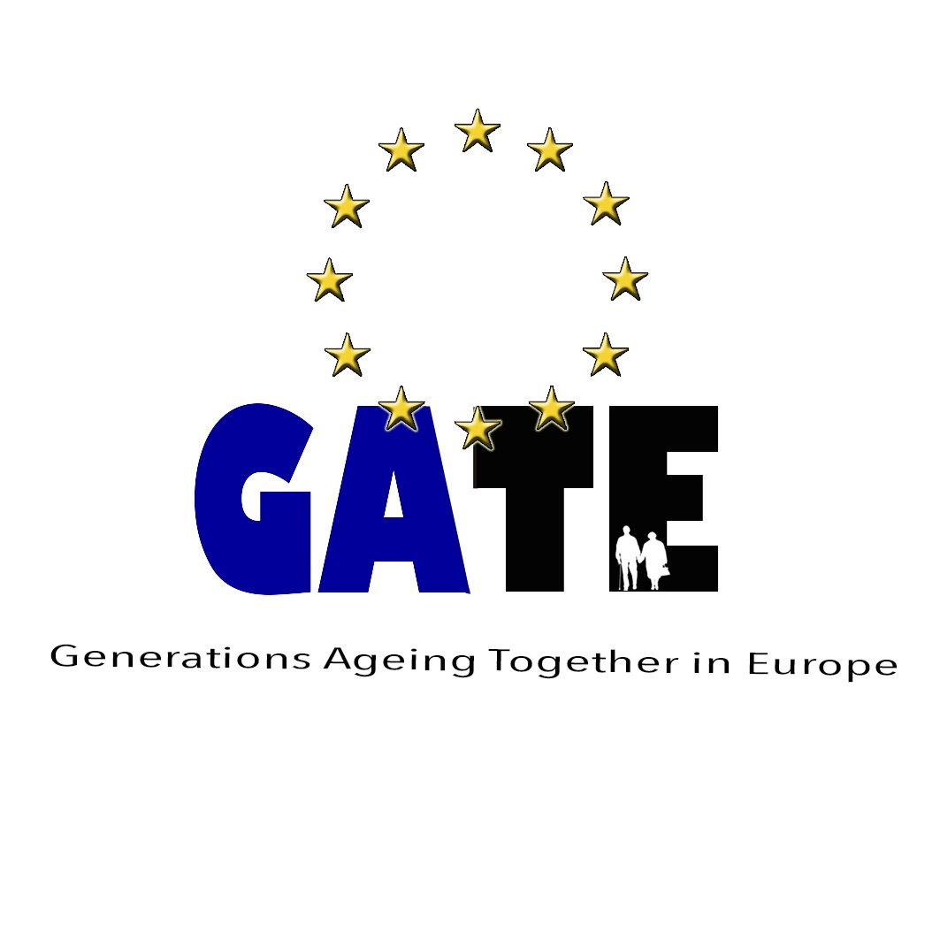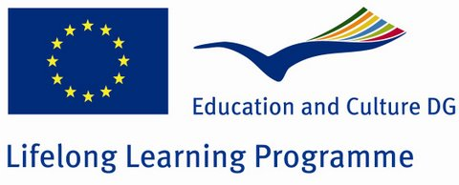

GATE
Generations Ageing Together in Europe
www.wea-ni.com/gate

Project Handbook

November 2012
Contents

- The GATE Project
1.1 Project Summary
1.2 Objectives
1.3 Activities
1.4 Outcomes
1.5 Target Group
1.6 Duration of the Project

- Project Organisation
2.1 Project Partners
2.2 Partner Contact Details
2.3 Overview of Partner Organisations
2.4 Roles and Tasks of Partners
2.5 Communication during the Project

- Project Structure
3.1 Work Packages
3.2 Project Meetings
3.3 National Workshops/Local Activities
3.4 Timetable of outcomes

- Dissemination

- Project Evaluation

Appendix

1. The GATE Project – Generations Ageing Together in Europe

1.1 Project Summary
Active ageing is the process of optimising opportunities for health, participation and security in order to enhance the quality of life as people age. It does not only refer to the ability to be physically active but to continuing participation in social, economic, cultural and civic affairs. Active ageing aims to extend healthy life expectancy and the quality of life for everyone as they age. Given that we all age within the context of family, friends, neighbours etc. active ageing must therefore be looked at from an intergenerational perspective. The main purpose of this project is to encourage reflection on active ageing and what this means for EU citizens. More specifically through the project we will bring together older people from the member states to discuss what active ageing means to them and raise awareness of the importance of active ageing to help ensure that older people are able to remain in the labour market for longer, to prevent social exclusion by encouraging participation in their communities and to help prevent dependency as people get older. We will particularly target older people who are marginalised and from the most vulnerable social groups and will look at the factors that contribute to active ageing and how small measures and initiatives can promote health and well being. The project will furthermore examine the role of education in advancing the active ageing agenda and develop a framework of learning. The role of local governments, health bodies and other stakeholders will be considered along with the need for collaborative working among all parties. National workshops will allow the discussions to include the views and opinions of the different generations and embed the concept that the changing demographic is an issue for all ages.

1.2 Project Objectives
The objectives of the partnership:
- To facilitate discussion and debate on active ageing among learners and partner organisations - what does it mean? How can it be achieved?
- To facilitate the exchange of knowledge, experiences and good practice in promoting and engaging older people in active ageing strategies.
- To encourage critical reflection on current practices
- The development of an internet platform to highlight the work and outputs of the partnership
- The development of tools to promote good practice
- The development of a GATE handbook with results and outputs of the project
- To discuss innovative practices to engage the most vulnerable older people in active ageing activities at a community level
- To increase knowledge of active ageing strategies and programmes in partner countries.
- To examine and explore the role of education in active ageing strategies
- To explore and examine the role of government, health bodies and other stakeholders in active ageing strategies and how they can work together collaboratively.
- To encourage older peoples involvement in the ageing debate
- To encourage and strengthen dialogue between the generations.
- The development of a GATE framework for good practice in active ageing learning programmes
- To foster intercultural learning and facilitate intercultural dialogue

1.3 Project Activities
- Project Meetings and discussion of -
  - Active Ageing
  - The role of education in active ageing strategies
  - Collaborative working of key stakeholders
  - Age friendly environments
  - Intergenerational approach to active ageing
  - Life course approach
  - Engaging the most vulnerable older people
  - Barriers and Benefits

- Finding good practice in active ageing education among partners and wider through exchanging knowledge and critical reflection on current practice

- Internet Based Research
  - Current Policies, Practices and Research
  - Local, Regional and European level
  - Can we learn anything from outside Europe?

- National Workshops/Local Activities
  - Discussion on format of workshop/activity
  - Topics for workshop/activity
  - Intergenerational/Generations Ageing Together

- Developing Project Logo, Leaflet and Webpage

- Developing GATE Good Practice Framework

- Writing GATE Guide

1.4 Project Outcomes
- Project Leaflet

- Project Webpage

- GATE Guide

- GATE Framework of Good Practice

1.5 Target Group
We will particularly target older people who are marginalised and from the most vulnerable social groups.

1.6 Duration of the project
The project will run from 01 August 2012 and 31 July 2014

2. Project Organisation
2.1 Project Partners

- Workers Educational association (WEA) - Belfast Northern Ireland (coordinator)
- University of Leicester, Institute of Lifelong Learning - Leicester, UK
- bia-net Netzwerk Bildung im Alter - Graz, Austria
- Ilustre Colegio Oficial de Químicos de la Comunidad Valenciana - Valencia, Spain
- Club Amici di Salvatore Quasimodo - Roccalumera, Sicily
- U.I.L. Pensionati del Trentino – Trento, Italy

2.2 Overview of Partner Organisations

WEA
The WEA Northern Ireland is the leading voluntary sector provider of adult education in Northern Ireland, providing learning to over 3000 people per year. Its vision is of a prosperous, creative and cohesive society where everyone is a learner. Its mission is to make learning irresistible. It has three strategic aims: to enhance prosperity; to foster social cohesion; and to promote lifelong learning.

The WEA NI targets all adults over the age of 16 to encourage participation in education and training opportunities. We operate in community settings which help to encourage the participation of those adults who would not normally avail of opportunities offered through more institutionalised settings. Many of the WEA’s programmes are aimed at disadvantaged groups who are marginalised from learning due to income, location or poor previous educational experiences.

The WEA NI has its main office in Belfast, with offices also in Derry/Londonderry and Enniskillen. Currently there is a staff of 20. The WEA offer a range of programmes including a Men’s Health Programme, Creativity Thirst Programme, a Learning to Earning Programme, Learning in a Shared Society and the Learning Age Project (LAP) which is specifically aimed at learners aged 50 and over.

The Learning Age Project (LAP) specifically targets learners over the age of 50 who face isolation, particularly in rural areas, to those with low incomes and to the educationally disadvantaged. It aims to promote social inclusion and active ageing through involvement in educational opportunities.

WEA actively promotes the inclusion and participation of all adults and works with local communities in targeting those at risk of social exclusion, adults with disabilities and minority groups. LAP is currently involved with a number of day centres, sheltered housing associations and support groups. We have delivered training to organisations working with those suffering from Parkinson’s disease, dementia and adults with learning and other disabilities.

Bia-net Netzwerk Bildung im Alter
Bia-net is a registered not-for-profit association, founded in 2008, with the central purposes:
• Promoting the topic LEARNING IN SENIOR AGE
• Promoting exchange of experiences between our members in the field of LEARNING IN SENIOR AGE
• Promoting cooperation and partnership of organisations and individuals who work with older people
• Developing sustainable regional, national and European networks

Fields of activities of bia-net are initiatives and projects with and for older people and adults, concept and project development, application and implementation of projects at national an European levels, monitoring of projects. bia-net is responsible for the organisation of the “Summer academy for Lifelong Learning for Seniors”, each year in July at the Karl-Franzens-University in Graz, which offers LLL for seniors, each year with a special topic. bia-net founded and lead the “Netzwerk Bildung im Alter” – “network for learning in later life” in Graz. Besides bia-net offers workshops and seminars in the field for organizations who work with seniors.

University of Leicester
The University of Leicester is a leading teaching and research university. One of only a handful of British universities in the world’s top 200, the University is ranked 12th (out of 118) in the UK. The University of Leicester is a member of the ‘1994 Group’ of internationally-recognised, research-intensive universities that share a commitment to research excellence. The University has an annual turnover of £220 million and research income of over £45 million (approx. €58.5million) each year. It was named the UK’s University of the Year in 2008–09. The judges cited Leicester’s “commitment to high quality, a belief in the synergy of teaching and research and a conviction that higher education is a power for good”. The University also won the Times Higher Education award for Outstanding Student Support 2009–10.

The University of Leicester has a long tradition of providing a wide range of adult education. Each year there are some 3,500 enrolments on Leicester Institute of Lifelong Learning (LILL) courses, while over 4,500 people attend other events, including activities in the Richard Attenborough Centre for Disabilities and the Arts. LILL works closely with partners in the region, including many voluntary groups.

As well as the teaching activities, the Institute of Lifelong Learning has an extensive research programme. Much of this research focuses on the ageing society, lifelong learning and the benefits for older people, through the work of the Leicester Learning and Ageing Group (LLAG). LLAG has established an international reputation for its research and has been involved with a number of Grundtvig projects. LLAG’s work seeks to show the potential benefits to individuals, families, communities and the state that can arise from lifelong learning in an ageing society. Learning in later life can promote greater social capital, stronger communities, and enable older peoples’ voices to be heard.

Ilustre Colegio Oficial de Químicos de la Comunidad Valenciana
The Official College of Chemicals of Valencia was founded in 1952 is a non-profit organization that defends the interests of graduates in chemistry from Valencia (Spain). Currently the College has 900 colleges. The College has several Technical Sections (Environment, Entrepreneurship, Senior, Wine Culture, Self-Employed, Occupational Hazards and Teaching). Senior Section intends to use the knowledge acquired during a lifetime by professionals who have completed their working lives. This section promotes professional help mainly entrepreneurs and senior chemistry students requiring guidance.

Club Amici Salvatore Quasimodo
The association called “Club Amici Salvatore Quasimodo”, with headquarters in Via Umberto I Roccalumera – Torre Saracena, was established February 16, 2003, as a management entity of the places of Literary Park Salvatore Quasimodo of Roccalumera. It aims to promote the work of the poet Salvatore Quasimodo, Nobel Prize for Literature in 1959, through constant cultural action that works through training (throughout life) through traditional systems, both through modern technological tools (websites, literary and cultural tours, e-learning, virtual museum etc..) and with the marketing of products related to Quasimodo, but also to its territory, or "The Incomparable Earth."

The Club has established an international organization; headquartered in Vienna at the Italian Cultural Institute in Austria (an organization of Italian Foreign Ministry) is open to accession by all who recognize the high-profile human, social and literary poet. The park literature dedicated to Salvatore Quasimodo rises in 1998, co-financed from Development SpA Italy, the Fondazione Nievo and the Italian Touring Club, under the Community Grant Global Literary Parks. " Club Friends of Salvatore Quasimodo, born of the experience of the International Civil Commitment incorporated in Messina, which has promoted the prestigious project promoted by, among others, by the Presidency of the Council of Ministers. About 250 projects brought before the European Commission only 17 were subject to financing and the project "Quasimodo" occupies among them, proudly, the tenth position.
The Association works with Universities, State and Private Schools, Local Authorities, as well as Provinces and International Organizations. The Association promotes events and social and cultural activities, especially directed at the most vulnerable and marginalized people of the area, addressed to the elderly, young and immigrants.

U.I.L. Pensionati del Trentino
Since few years, UIL pensionati Trentino is benchmarking its own experience with similar associations in other countries. It does so while remaining focused on all the typical issues affecting its associates such as health, income, assistance, etc..
This has allowed our association to get in touch with different modalities to manage the issues related to age in the field of health, assistance and foremost the management of free time.
The medical progress and the increased wealth are indeed generating longer life expectancy that, as effect, is increasing the amount of free time available in the post-retirement age.
Cultural exchanges, permanent education and inter-generational relationships are becoming important elements for people to grow older while remaining active. In addition, they allow a high degree of independency of the individual, who does not represent a cost for the public system.
UIL pensionati Trentino operates on a region located at the border (Trentino Alto Adige), with people of different cultures and languages such as: Italian, German and Ladino. This forces the association to continuously open up to new cultures.
In addition, there has been a change in the emigration flow in the last few years. Our territory has, indeed, moved from a place of emigration into a region of immigration. This has required even more the need to open up our work to new cultures with particular attention to regions such as North Africa, Romania, Ukraine, Albania, etc..
For this reason, the need to understand cultures is more than ever present in the life of older people, who are today more inclined as well to a wider cultural openness.
UIL pensionati Trentino counts today 2373 members and an average age of about 70. The most important activity of the association is personalized consultancy to their members with regards to the pension system and lobbying activity with the local public authorities to increase quality and offering of the public services rendered to the association members.
UIL pensionati Trentino is also paying particular attention to the quality of life in relation with the external environmental health.

2.3 Partner Contact Details
 | Organisation | Address | Web address | Contact | Tele | Mobile | Email | Skype
1 | WEA –  Workers Educational Association | 3 Fitzwilliam Street  Belfast  BT9 6AW  Northern Ireland | www.wea-ni.com | Carolyn Hale | 00442890329718 | 00447955511008 | carolyn.hale@wea-ni.com | Carolyn.hale12
2 | Bia-net  Netzwerk Bildung im Alter | Schockelblickstrasse 2  Graz  8044  Austria | www.bia-net.org | Manuela Hinterberger | 004369914170038 |  | manuela.hinterberger@bia-net.org | Phone2manu
3 | University of Leicester | University Road  LE1 7RH  Leicester  United Kingdom | www.le.ac.uk/lifelonglearning | John Benyon | 00441162525922 |  | jtb2@le.ac.uk
4 | Ilustre Colegio Oficial de  Químicos de la Comunidad Valenciana | C/Asturias, 19  46023  Valencia  Spain | www.colegioquimicos.com | Pedro Rodriguez | 0034963375377 | 0034609415488 | pedro@atq.es | pedroatq

5 | Club Amici di Salvatore Quasimodo | Via Umberto 1  Torre Saracana, 98027, Roccalumera  Sicily, Italy | www.parcoquasimodo.it | Carlo Mastroeni | 00390942745300 |  | avv.carlomastroeni@gmail.com
6 | U.I.L. Pensionati del Trentino | Via Matteotti, 22  Trento  38122  Italy | www.uilpensionatitn.org | Claudio Luchini | 00393337773476 |  | Luchini.claudio@libero.it

2.4 Role and Tasks of the Partners

Role of the coordinator:
As coordinating partner, the WEA will be responsible for
  - Overall management and direction of the project process
  - Clear communication among partners
  - Administration and the monitoring of progress according to agreed timescales
  - Collecting information from individual partners and disseminating across the partnership and beyond
  - Presiding at trans-national meetings, documenting them and producing and monitoring action plans.

Role and tasks of partner organisations: (will include the active involvement of all partners)
- Design of project logo
- Production of project leaflet
- Production of project webpage
- Taking part in all transnational meetings and contributing information and presentations as required
- Providing information on active ageing strategies in their own countries
- Reporting findings and outcomes form national workshops
- Coordinating the transnational meetings in their home country
- Promoting later life learning and active ageing in the home regions
- Contributing to the GATE web page
- Contributing to the planned GATE Guide
- Contributing to the Good Practice Framework
- Dissemination and Exploitation of project results and outputs
- Translating GATE outputs

2.5 Communication during the Project
The coordinating partner will be responsible for ensuring that all partners are working together effectively and that there are multiple channels of communication available. Email, telephone and Skype contact will be the main communication methods used between transnational meetings. The first meeting will be particularly important for team building and clarifying an overview of the partnership work programme, clearly outlining and agreeing key targets and corresponding deadlines. The learners involved may not all have access to the Internet (nor indeed have those skills) but this will not be a barrier to their participation and we will ensure that communication nationally will include them – perhaps through a bi-monthly written update. We will also seek permission from the older learners to share postal addresses, e-mail addresses etc with each other.

3.Project Structure

3.1 WORK PACKAGES

Work Package 1: October 2012 – March 2013
Developing Project Structures

Activities
- Kick off meeting
- Developing project structures
- Detailed working plan including tasks
- Timetable of project meetings
- Design project logo & leaflet
- Communication design
- Develop dissemination plan
- Evaluation design
- Develop project webpage
- Develop framework for workshops/local activities and internet research
- Recruiting for national workshops/local activities
- Project handbook
- Discuss GATE guide content

Outputs
- Agreed project structures
- Developed and agreed working plan, tasks and timetable.
- Project logo and leaflet designed
- Agree dates and locations of project meetings
- Evaluation strategy developed
- Dissemination strategy agreed
- Communication plan agreed
- Project webpage online
- Agree framework for workshops/local activities and internet research
- Agreement of agenda for national workshops
- Project handbook completed and distributed to all partners
- Agree first draft of GATE guide content
- Evaluation WP 1

Work Package 2: March 2013 – June 2013
Active Ageing

Activities
- Sharing results of internet research
- Intergenerational workshops/local activities on active ageing
- Finding a common definition of active ageing
- Agreeing terminology
- Second project meeting
- Agreeing contents of GATE guide
- Updating the webpage
- Dissemination and evaluation
- Writing up part of GATE guide – Active Ageing

Outputs
- Collation of internet research
- Report from national workshops/local activities
- Agreed definition of active ageing
- Index of contents for the guide
- First section of guide - Active Ageing completed
- Documented and evaluated second meeting
- Project leaflet in all project
languages
- Evaluation of WP 2
- Webpage updated

Work Package 3: June 2013 – October 2013
Current Policies, Practice and Research

Activities
- Sharing results of internet research
- Intergenerational workshops/local activities
- Writing the section of the guide on current practices and policies in active ageing
- Collecting previous EU projects for active ageing education
- Third project meeting
- Updating the webpage
- Dissemination and evaluation

Outputs
- Collation of internet research
- Report from national workshops/local activities
- Second part of guide completed.
- Documented and evaluated third meeting
- Evaluation of WP 3
- Webpage updated
- Dissemination of results and outputs to date

Work Package 4: October 2013 – March 2014
GATE Framework of Good Practice

Activities
- Carry out Internet research
- Intergenerational workshops/local activities
- Discuss and document intergenerational/life course approach to active ageing
- Developing draft of framework for good practice in active ageing
- Preparing GATE guide
- Fourth project meeting
- Updating the webpage
- Dissemination and evaluation

Outputs
- Sharing of Internet research
- Report from national workshops/local activities
- Draft of framework for good practice
- Draft of the final version of the guide
- Documented and evaluated
fourth meeting
- Evaluation of WP 4
- Disseminating results and outputs to date

Work Package 5: March 2014 – July 2014
The GATE Guide

Activities
- Carry out Internet research
- Intergenerational workshops on active ageing
- Finalising the framework of good practice
- Finalising the GATE guide
- Project meeting 5
- Updating the webpage
- Dissemination and evaluation
- Project Evaluation

Outputs
- Sharing of Internet research
- Report from national workshops/local activities
- Final version of the framework of good practice
- Final version of the GATE guide
- Documented and evaluated fifth meeting
- Evaluation of WP 5
- Disseminating results and outputs of the project
- Updated web page
- Evaluation of the project
3.2 MEETINGS

Timetable of meetings:
- Belfast 29 Oct – 01 Nov 2012
- Valencia 3 Mar - 6 Mar 2013
- Trento 16 June – 19 June 2013
- Sicily 27 Oct – 30 Oct 2013
- Austria March 2014
- Belfast June 2014

Meeting 1: Belfast – 29 October – 01 November 2012
- Presentation of all partners
- Teambuilding
- Discuss and agree project structures
- Discuss and agree work plans
- Agree timetable for project meetings
- Distribution of project tasks
- Discussion on dissemination, communication and evaluation
- Discuss national workshops/local activities
- Intergenerational work/Life course approach
- Agree framework for workshops/local activities and internet research
- Agreement of project logo
- Agreement of project leaflet
- Agreement of project webpage
- Discussion on GATE guide and framework of good practice
- Agree first draft of GATE guide content
- Plan and tasks for next meeting

Meeting 2: Valencia - 3 March – 6 March 2012
- Report on national workshops/local activity/internet research
- Partner presentations on understanding of active ageing & examples from own locality
- Dissemination activities
- Agreement on the index of contents for the GATE guide
- Agree definition of active ageing. Consider -
    - Employability
    - Social and civic participation
    - Non deficit model of ageing
- Intergenerational/life course approach approach
- Engaging the most vulnerable older people – disparity in life expectancy and healthy life expectancy
- Consider barriers and benefits
- Agree first part of guide - introduction and context
- Agree second part of guide – active ageing
- Involving older learners
- Evaluation WP 1
- Evaluation meeting 2
- Plan and tasks for the next working package

Meeting 3: Trentino – 16 June – 19 June 2013
- Report on national workshops/local activities/internet research
- Dissemination activities
- Discussion on good practice and effective strategies in active ageing
- Current practices, strategies and policies in active ageing
- Discussion on role of education in active ageing
- Collaborative working – key stakeholders
- Agree second part of guide – practice & policies
- Involving older learners
- Evaluation WP 2
- Evaluation meeting 3
- Plan and tasks for the next working package

Meeting 4: Sicily – 27 October – 30 October
- Report on national workshops/local activities/internet research
- Dissemination activities
- Age friendly environments
- Agreeing content and structure of framework of good practice
- Agree part of guide – intergenerational/ life course approach
- Involving older learners
- Evaluation WP 3
- Evaluation meeting 4
- Plan and tasks for the next working package

Meeting 5: Graz – March 2014
- Report on national workshops /local activiites/internet research
- Dissemination activities
- First draft of GATE guide
- Develop draft of framework of good practice
- Preparing the final meeting
- Involving older learners
- Evaluation WP 4
- Evaluation meeting 5
- Plan and tasks for the next working package

Meeting 6: Belfast – June 2014
- Presentation of the project and the outcomes
- Dissemination activities
- Final version of GATE guide
- Final version of framework of good practice
- Involving senior learners
- Evaluation WP 5
- Evaluation of meeting and GATE project
- Update web page

4. Evaluation
Monitoring of the project is important to ensure efficient and effective progress is made at all stages and in maintaining high standards of quality on all aspects of the work being undertaken. Each phase of the project will have a clear and achievable set of aims, objectives and expected outcomes. Progress will be measured and evaluated at the end of each package using oral feedback and questionnaires. This will ensure that the project's implementation will develop as planned and that any problems are highlighted and dealt with quickly.

There will be a formal end of project evaluation assessing how the organisations and the learners felt the project had met its aims and objectives.

All partners will undertake to regularly monitor and evaluate each stage of the project to ensure high standards of quality are maintained throughout. All partner organisations have in place rigorous quality assurance procedures within their own organisations which will be utilised to form the basis of the quality assurance and evaluation plan.

- Evaluation at end of each project meeting (see appendix A)

- Evaluation at the end of each working package (see appendix B)

- End of project evaluation (see appendix C)

5.Dissemination
Dissemination will have an overriding role in the project as it is a crucial factor in ensuring the activities and results of the project are of a transnational, intercultural nature and are transferable to other contexts. Partners will jointly develop a dissemination plan which will be appropriate for all settings and will ensure maximum exposure for the project at European,regional and local levels. The dissemination plan will be flexible to allow for any developments to be incorporated as the project evolves. All partners will use local, regional and national contacts to disseminate the experiences and results. Partners will record all dissemination activities in an agreed format (see appendix D) and will present this at the end of each work package. The coordinator will be responsible for collating this information.

Other methods of dissemination will include -
  - Project webpage and discussion forum
  - Producing a project leaflet outlining the details of the project, aims, objectives and expected outcomes
  - Distribution of flyers and leaflets
  - Meetings with colleagues, other age sector and education organisations, senior groups in all participating countries, the Eubia network, AEA and the wider community sector.
  - Media and press releases
  - Conferences and seminars

The older people will be involved in the dissemination process through
  - Sharing their experiences of the project with their own local groups and forums.
  - Speaking at meetings, conferences and seminars about their experiences
  - Involvement in writing reports and articles for newsletters and webpages
  - Involvement in discussion forum

Appendix A

GATE – XXX Project Meeting
Location – XXX to XXX

Meeting Evaluation Form
(scales from 1=very good to 5=not at all satisfying)

1. I found the organisation of this meeting

1 2 3 4 5

Comments:

2. I evaluate the contents of this meeting as …

1 2 3 4 5

Comments:

3. I found my own involvement in and my contributions to this meeting …

1 2 3 4 5

Comments:

4. The meeting served to realise the objectives of the project…

1 2 3 4 5

Comments:

5. The meeting fulfilled my expectations to the meeting

1 2 3 4 5

Comments:

6. My general impression of this meeting is ….

1 2 3 4 5

Comments

7. Other comments

Appendix B

Evaluation workpackage XXX

We would be very grateful if you would take some time to complete this questionnaire. Your information will be treated as confidential.

This is the evaluation for WP XXX (from-to).
Please answer the following questions.

01 | What were your main hopes and expectations for WPX?
02 | To what extent were these expectations met?
03 | What did you enjoy most during the WPX?
04 | What did you learn during WPX?

Please read the following statements related to the work developed within WPX and answer by ticking a box that corresponds to your opinion, with reference to a scale from completely disagree to completely agree.

 |  | Completely disagree | Disagree | Agree | Completely Agree
05 | The work was appropriate to the needs of project development |  |  |  | 
06 | The main outputs (XXXXXXXX) are in compliance with the proposal |  |  |  | 
07 | The results are a solid basis for WPX |  |  |  | 

Any additional comments:

08 | Do you have any concerns on the development of GATE project?
 | Project management | Concerns:
 | Methodology | Concerns:
 | Clearness of next steps and “to-do’s” | Concerns:
 | Internal communication | Concerns:
 | Compliance with deadlines | Concerns:
12 | Anything else you would like to say?

Thank you!
Appendix C

End of Project Evaluation

Appendix D

GATE - Dissemination list

Name of the organisation: Period:

Activity | Short description | Date | Nº individuals / organisations  concerned | Evidence annexed

